**Report**

**#Steps**

**Step 1 : Use Solr to index html files**

I downloaded Solr on the site <http://www.apache.org/dyn/closer.lua/lucene/solr/7.1.0> and use Terminal to star Solr.



And I created a new core called mySolarCore with the command: bin/solr create –c mySolarCore. There is also a new folder called mySolarCore under server->solr folder.

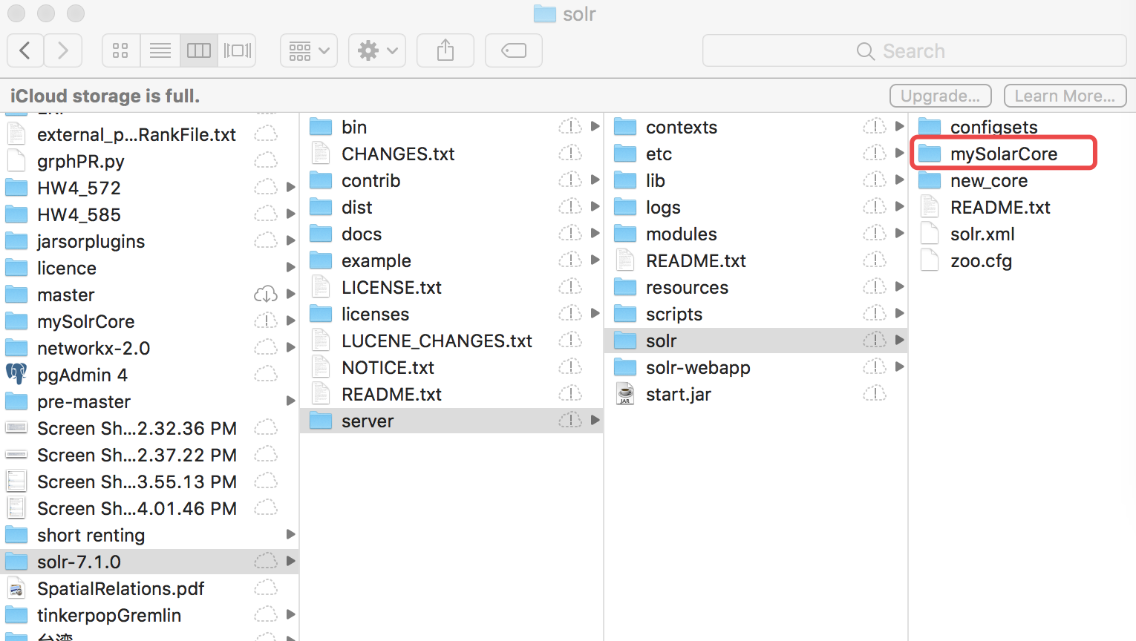

In addition, there are two files in mySolarCore should be configured. First, add <copyField source="*" dest="_text_"/> to managed-schema file in order to combine all the information from different in field “_text”. Second, add <str name=”df”>_text_</str> in defaults part to specify that queries search “_*text*_” defaultly. Third, reload mySolarCore in order to enable core to index files by following the new configuration.

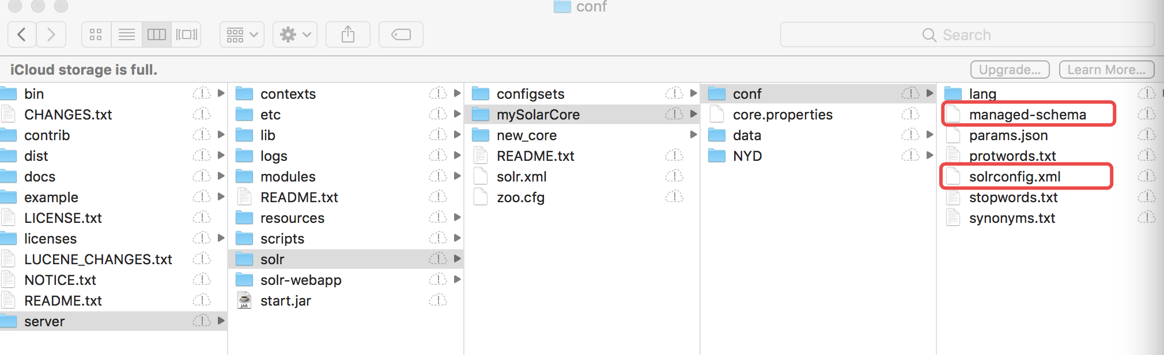

In order to index the NYD html files I put the downloaded NYD folder which contains related html files into mySolarCore folder and run Terminal command “bin/post -c mySolarCore -filetypes html server/solr/mySolarCore/NYD” to trigger Solr to index files. And got the results below and I also checked on <http://localhost:8983/solr/#/~cores/mySolarCore>

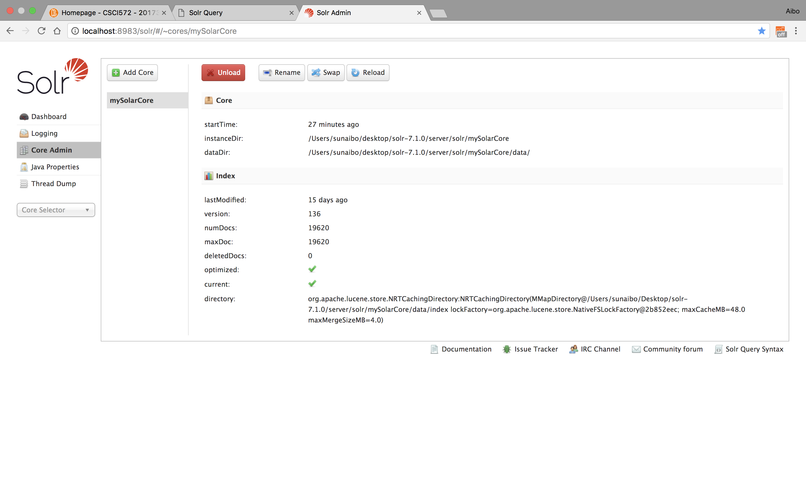

**Step 2 : Create a front end webpage.**

On the site <http://lucene.apache.org/solr/guide/7_0/using-javascript.html#using-javascript> I found using JavaScript could create client API which is a language I am familiar with, so I followed the site guidance use XMLHttpRequest mechanism to communicate with Solr. (Regarding detial implementation, please check the attached file-searchFrontEnd.html)

**Step 3 : Generate external_pageRankFile.txt**

Firstly, I downloaded jsoup-1.10.3.jar to outgoing links in each webpage and created a edgeList.txt file which contains pairs of all webpage with their outgoing links. Secondly, I used networkx to read edgeList.txt to get a graph as the input of PageRank algorithm and also let other arguments be alpha=0.85, personalization=None, max_iter=30, tol=1e-06, nstart=None, weight='weight',dangling=None. And then put the PageRank algorithm result into external_pageRankFile.txt file.

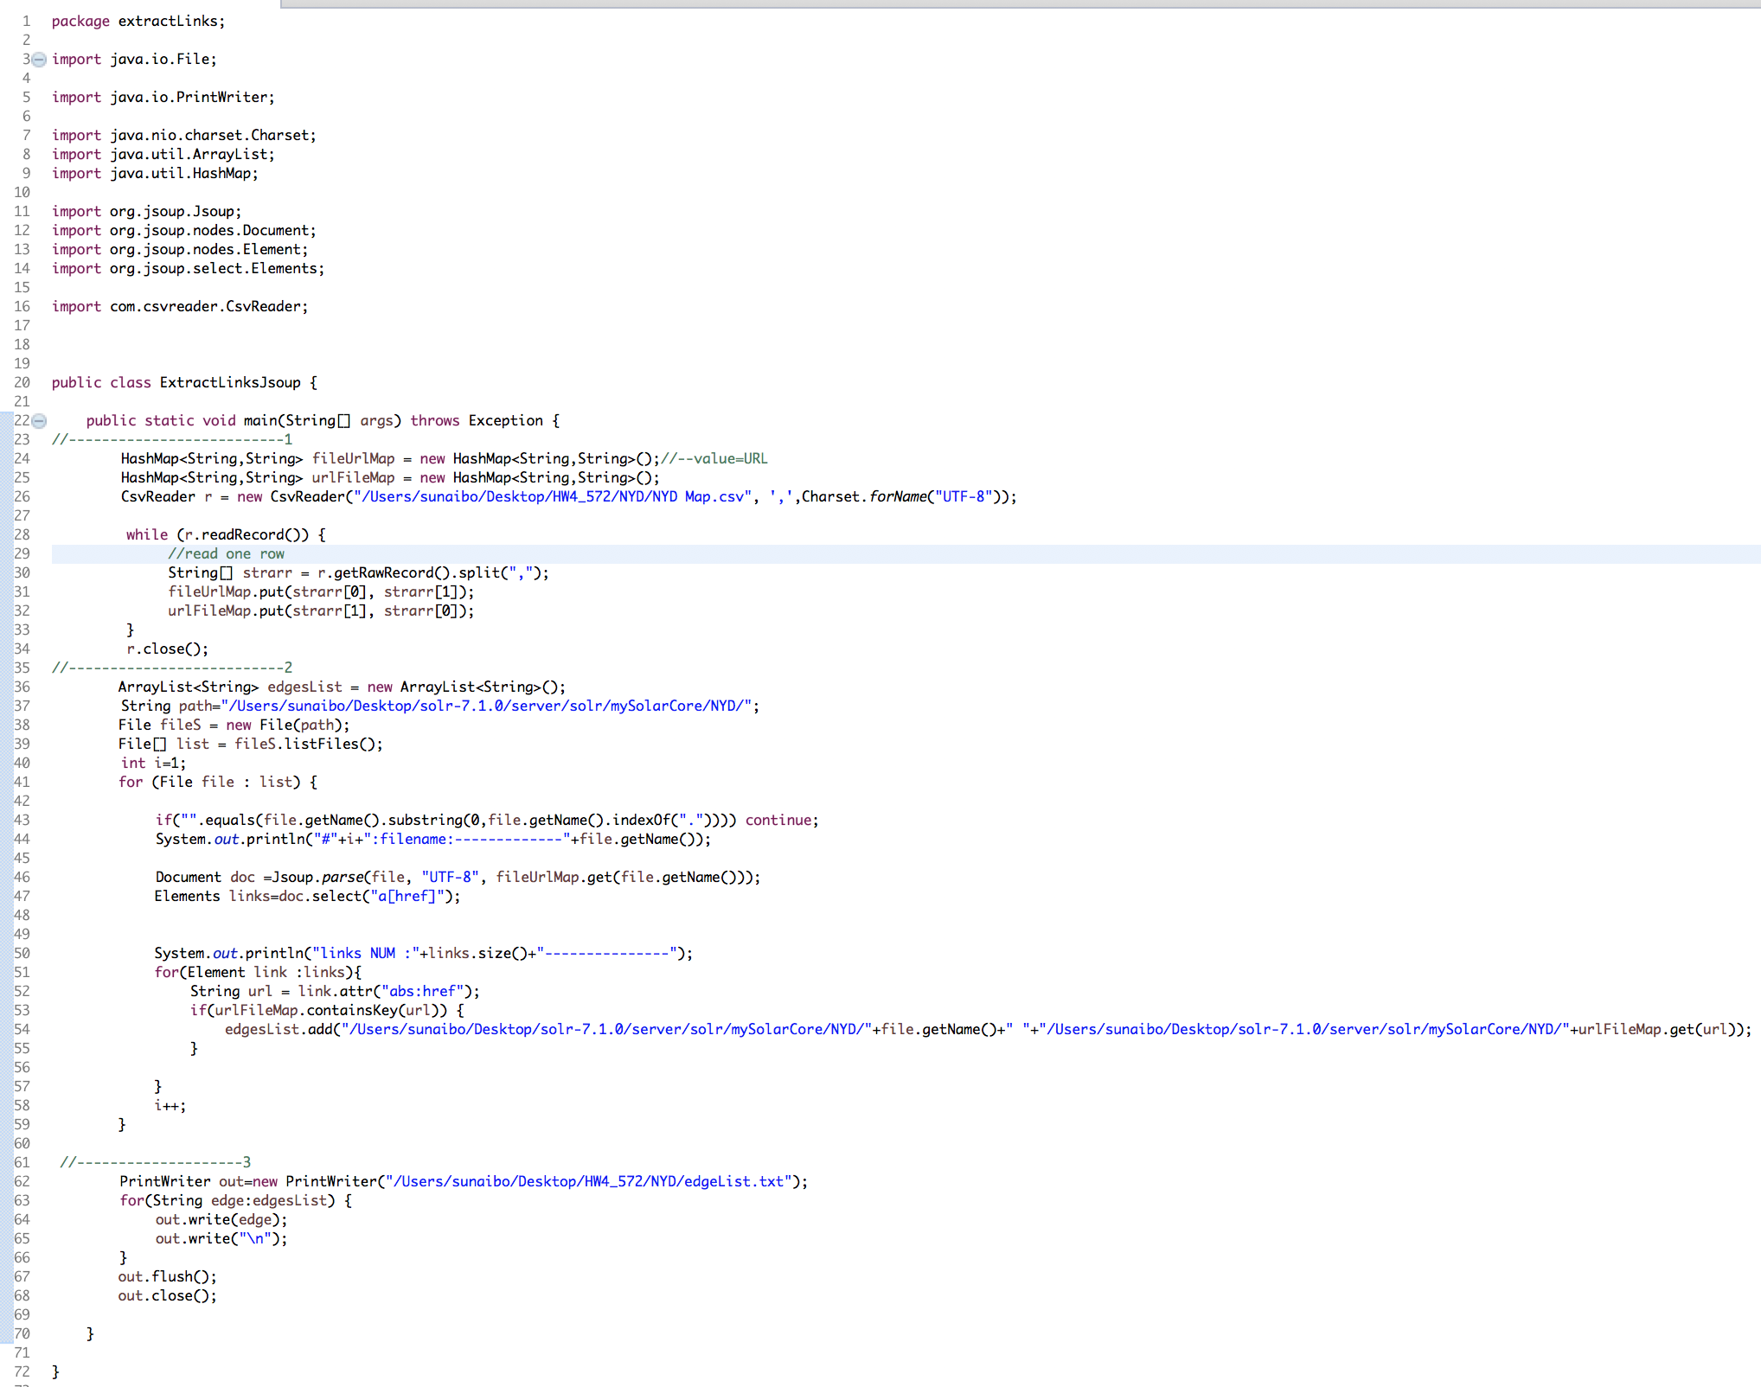

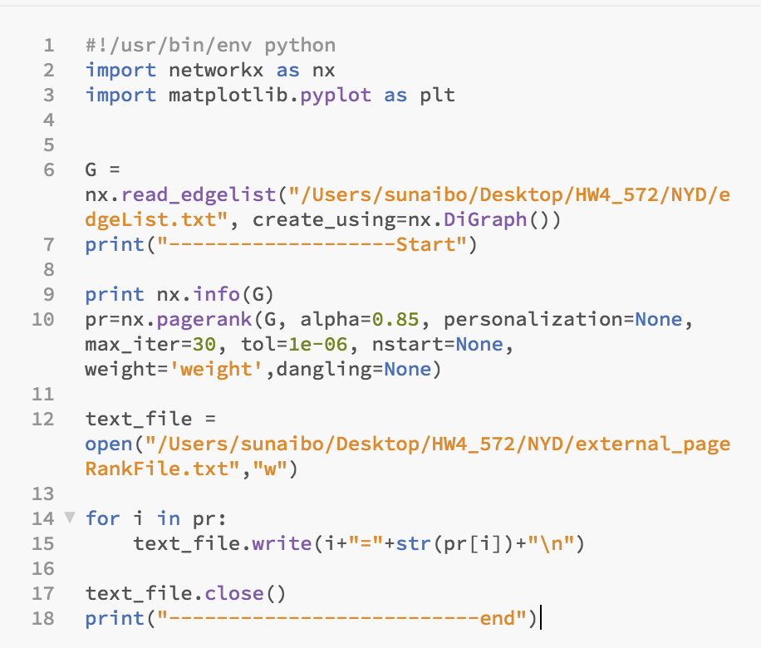

**Step 4 : Re-configure Solr and front end file to rank results in two method, default Defalt-Lucene and PageRank.**

Add “<fieldType name="external" keyField="id" defVal="0" class="solr.ExternalFileField"/> <field name="pageRankFile" type="external" stored="false" indexed="false"/>” into managed-schema file, and also define listeners in solrconfig file like this

“<listener event="newSearcher" class="org.apache.solr.schema.ExternalFileFieldReloader"/> <listener event="firstSearcher" class="org.apache.solr.schema.ExternalFileFieldReloader"/>”.

Reload mySolarCore again.

Moreover, modify my frond end html, for example, add radio button to enable it search results in two method.

**#Explanation**

As I used networkx to read edgeList.txt to get a graph as the input of PageRank algorithm and also make other arguments be alpha=0.85, personalization=None, max_iter=30, tol=1e-06, nstart=None, weight='weight',dangling=None. And then put the PageRank algorithm result into external_pageRankFile.txt file. Therefore, the PageRank algorithm of all webpage are the same logic, namely all rely on pagerank of those pages which are pointing to them. All the pages are internal site. Pages with more pages which point to them and have less out going links have higher. Like homepage <http://www.nydailynews.com/> , there are lots of pages pointing back to it, so it could have higher pagerank.

**# Screenshots describing entire flow of “Star Wars”**

1. Screenshot of initial page where you enter the query in input box.

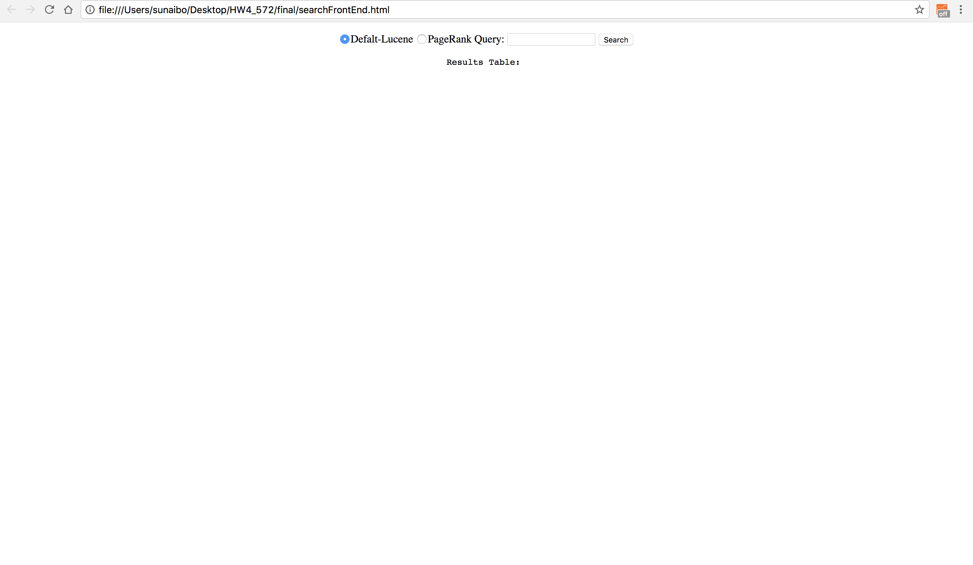

1. Screenshot of page which shows the results for Lucene(Default).

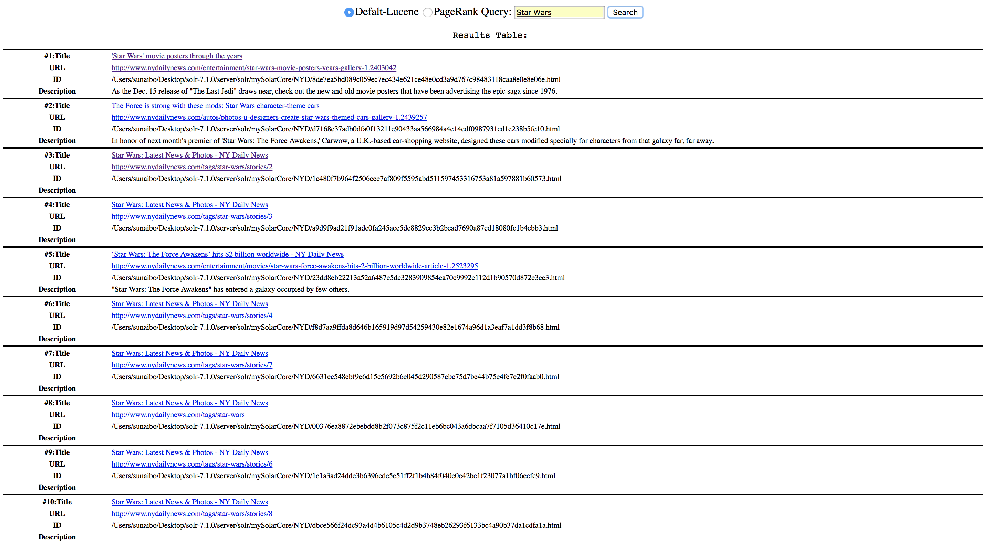

1. Screenshot of page which shows the results for PageRank.

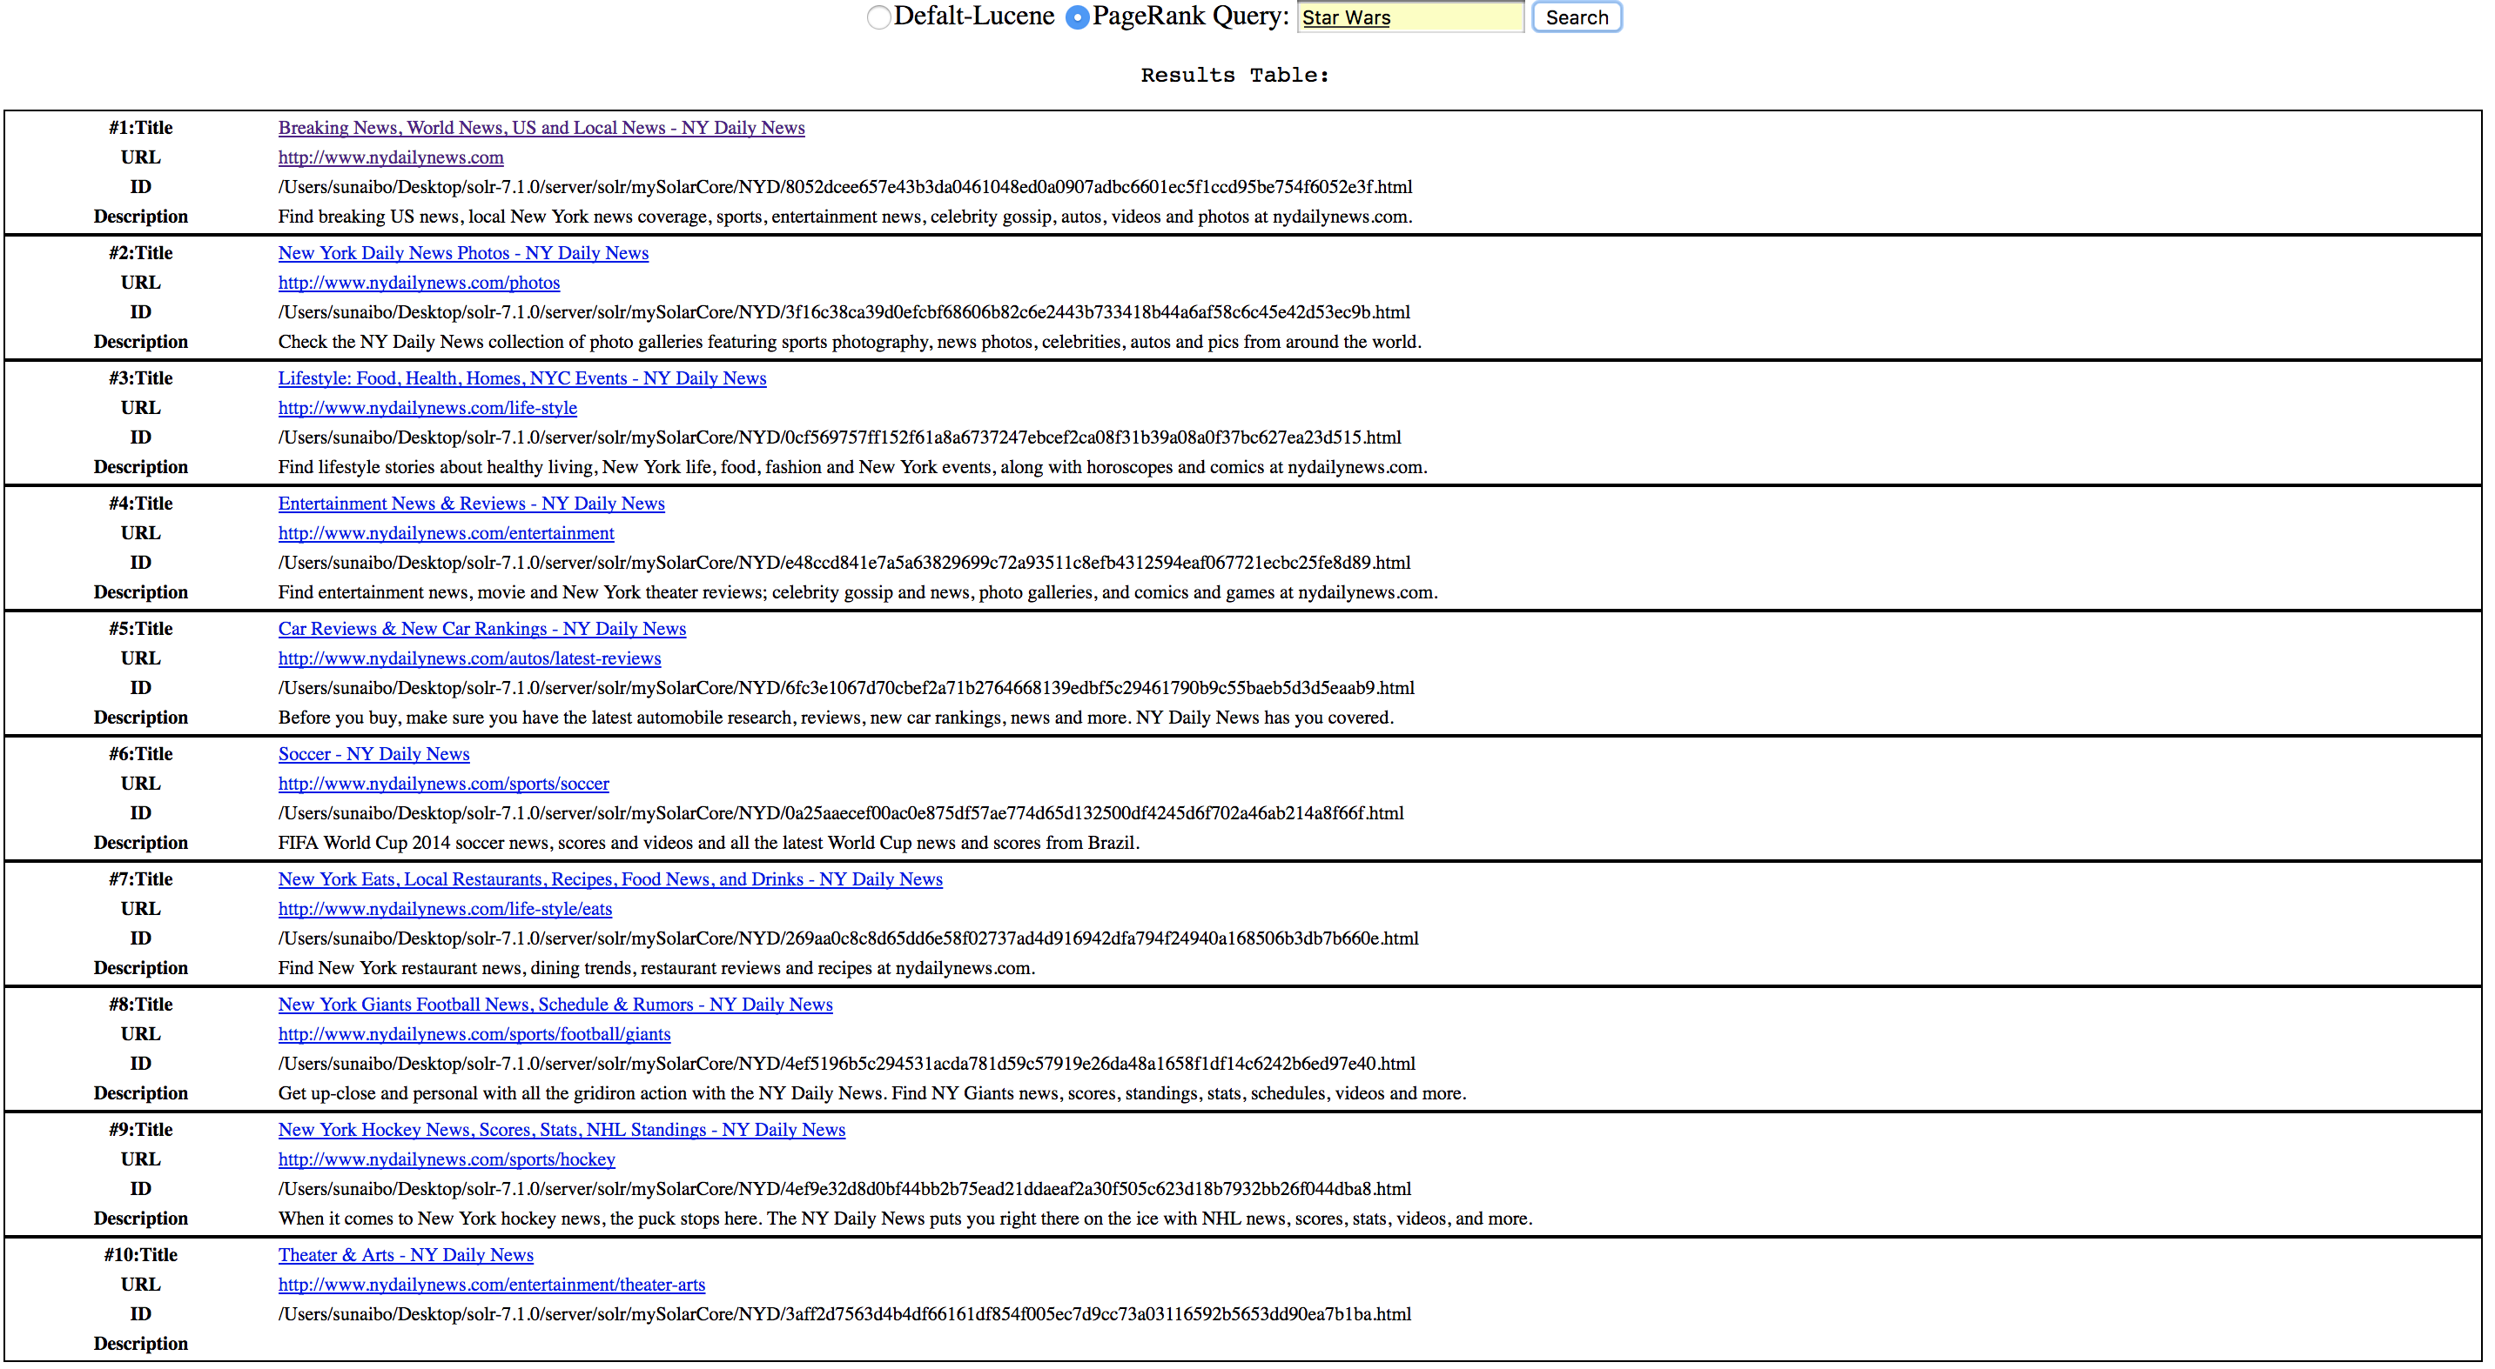

1. Screenshot of the actual webpage that opens when clicking on one of the result’s link



**#A table of all query top 10 URLs**















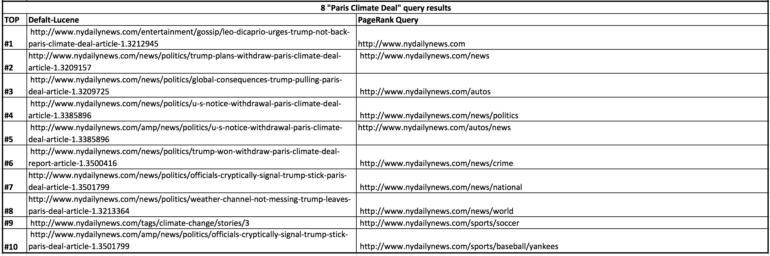

**#An overlap graph**

* There is no overlap between the two ranking strategies for all queries.